SOFTWARE DESIGN DOCUMENT
Smart Order and Inventory Management System

1. DOCUMENT CONTROL
Item | Details
Project Name | Smart Order Management System
Version | 1.0
Author | Rakesh Teja P V
Date | 29-12-25
Status | Final

2. PURPOSE OF THE DOCUMENT
This document describes the system architecture, design decisions, component structure, APIs, data models, and non-functional aspects of the Smart Order Management System.
It is intended for:
- Developers
- Reviewers
- Interview discussions
- Maintenance & enhancement planning

3. SYSTEM OVERVIEW
Business Objective
Provide a scalable, secure, and maintainable system to:
- Manage users
- Manage products
- Place and track orders
- Support growth through microservices
High-Level Features
- User registration & login
- Product catalog management
- Order placement & tracking
- Role-based access (USER / ADMIN)

4. Business Rules:
- Cannot cancel after 48 hr delivery scheduled date
- Stock Replenishment alert when current stock lesser than min stock level
- RBAC – Customer, Admin, Finance Officer

5. ARCHITECTURE OVERVIEW (HLD)

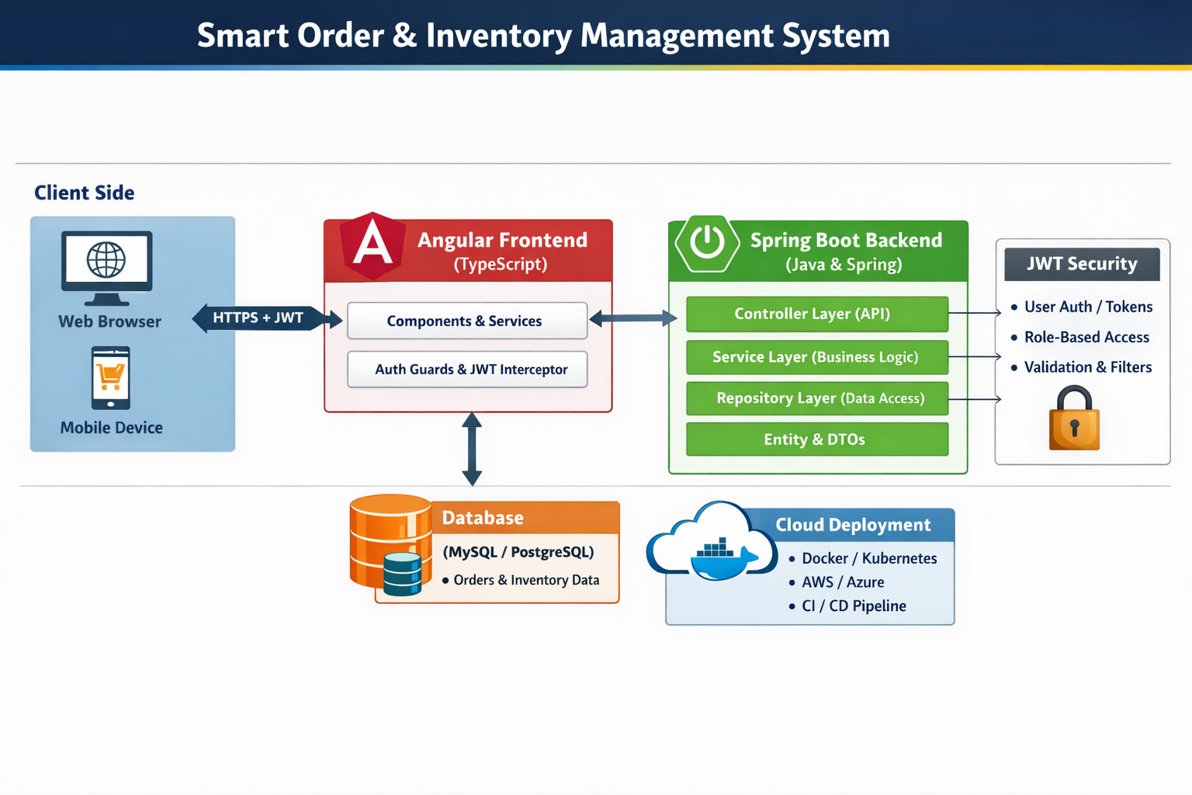

Detailed Architecture Diagram

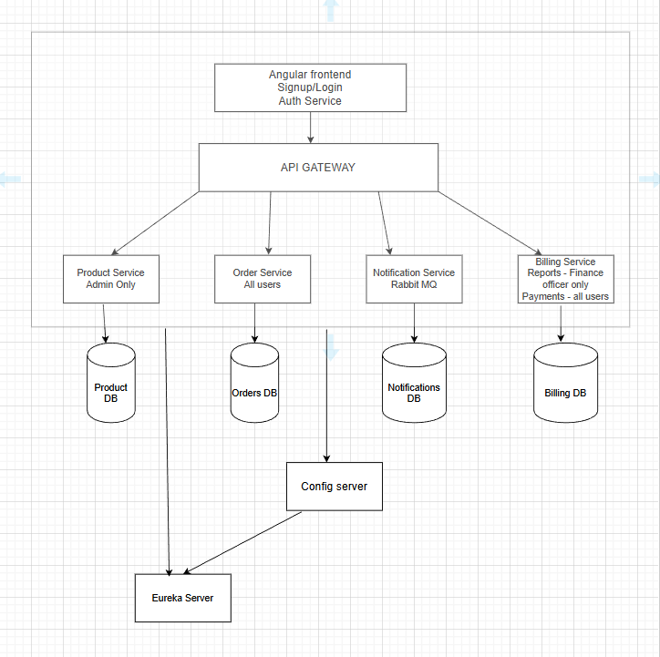

ER Diagram
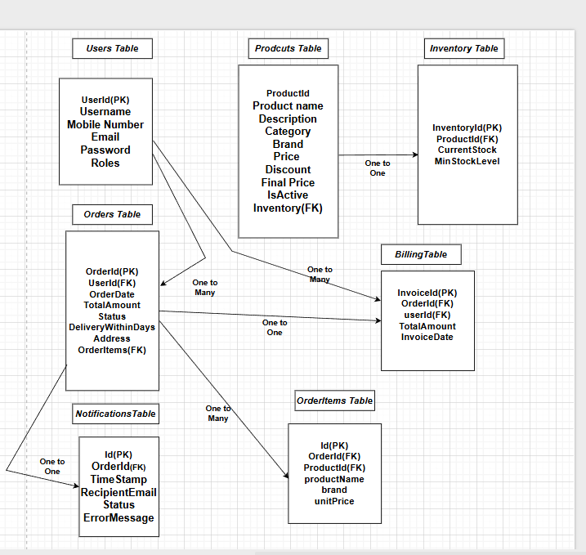

Architecture Style
- Microservices Architecture
- REST-based communication
- JWT-based security
- Containerized deployment (Docker)
- Scalable and loosely coupled design

Core Components
- Angular Frontend
- API Gateway (for routing and security – optional)
- User Service (Authentication & Authorization)
- Product Service (Product catalog management)
- Order Service (Order placement & tracking)
- Billing Service (Invoice & payment handling)
- Notification Service (Email / system notifications)
- MYSQL (Dedicated database per microservice)
- CI/CD Pipeline (Automated build, test, and deployment)

6. TECHNOLOGY STACK
Backend
- Java 17
- Spring Boot
- Spring Web
- Spring Data JPA
- Spring Validation
Frontend
- Angular
- Angular Material
- RxJS

Database
- MySQL(one DB per microservice)

DevOps
- Docker
- Docker Compose
- Jenkins
- SonarQube
Testing
- JUnit 5
- Mockito
- Spring Boot Test
- JMC
- JMeter

7. MICROSERVICES DESIGN
Entity design
Product Service:
Products - Id, name, description, category, brand, price, discount
Inventory - Id, productId(FK), currStock, minStockLevel
Order Service:
Orders - Id, customerId(FK), orderDate, totalAmount, Status, deliveryWithinDays, address
OrderItems - Id, OrderId(FK), productId(FK), quantity, unit cost
Notification Service:
Notification - Id, recipientEmail, orderId(FK), timestamp, Status
Billing Service:
Invoices - Id, orderId(FK), totalAmount, invoiceDate, status
Authentication Service:
Users - Id, username, mobileNumber, email, password, roles

7.2 User Service
Responsibilities
- User registration
- Authentication
- Role management
APIs

METHOD | ENDPOINT | REQUEST PAYLOAD | RESPONSE PAYLOAD
POST | /users/register | { name, email, password, role } | { userId}
POST | /users/login | { email, password } | { token, userId, role }
POST | /users/signout | - | { message }
PUT | /users/password/{id} | {currentPassword, newPassword} | -
Database
- users database

7.3 Product Service
Responsibilities
- Product CRUD
- Inventory management
APIs
METHOD | ENDPOINT | REQUEST PAYLOAD | RESPONSE PAYLOAD
POST | /product/add | {  "name": "Wireless Mouse",  "description": "Ergonomic wireless mouse",  "brand": "Logitech",  “specification”: {  "colors": ["Black", "White", "Blue"],  …  }  "price": 799.00,  "stock": 150  } | {  “id”:”P001”  }
GET | /products | — | [  {  "name": "Wireless Mouse",  "description": "Ergonomic wireless mouse",  "brand": "Logitech",  “specification”: {  "colors": ["Black", "White", "Blue"],  …  }  "price": 799.00,  "stock": 150  },  ….  ]
PUT | /products/{id} | {  "price": 899.00,  “specification”:{  "colors": ["Black", "Grey"],  }  } | 200 OK
DELETE | /products/{id} | — | 200 OK
GET | /products/{id} | - | {  "name": "Wireless Mouse",  "description": "Ergonomic wireless mouse",  "brand": "Logitech",  “specification”: {  "colors": ["Black", "White", "Blue"],  …  }  "price": 799.00,  "stock": 150  }
GET | /products/{name} | — | {  "name": "Wireless Mouse",  "description": "Ergonomic wireless mouse",  "brand": "Logitech",  “specification”: {  "colors": ["Black", "White", "Blue"],  …  }  "price": 799.00,  "stock": 150  }
GET | /products/filter | {  name: “mouse”;  brand: “Logitech”  } | {  "name": "Wireless Mouse",  "description": "Ergonomic wireless mouse",  "brand": "Logitech",  “specification”: {  "colors": ["Black", "White", "Blue"],  …  }  "price": 799.00,  "stock": 150  }

Database
- products collection

7.4 Order Service
Responsibilities
- Order creation
- Order history
- Order status
APIs

METHOD | ENDPOINT | REQUEST PAYLOAD | RESPONSE PAYLOAD
POST | /orders | {  "customerId": 12, "items": [ { "productId": 101, "quantity": 2 },  {"productId": 205, "quantity": 1 } ]  } | {  "orderId": 501,  "status": "CREATED", "totalAmount": 3499.00  }
GET | /orders/{orderId} | — | { "orderId": 501,  "status": "PACKED",  "items": [ { "productId": 101, "quantity": 2, "price": 999 },  { "productId": 205, "quantity": 1, "price": 1501 } ],  "totalAmount": 3499,  "warehouse": "BLR-WH-01"  }
GET | /orders/history | — | { "content": [ { "orderId": 501, "status": "DELIVERED", "totalAmount": 3499, "createdAt": "2025-12-27T10:45:12" }, { "orderId": 498, "status": "CANCELLED", "totalAmount": 1299, "createdAt": "2025-12-25T18:30:00" } ], "totalPages": 3, "totalElements": 21 }
DELETE | /orders/cancel/{id} | — | { "orderId": 501, "status": "CANCELLED", "message": "Order cancelled successfully" }
Database
- orders database

7.5 Billing Service

METHOD | ENDPOINT | REQUEST PAYLOAD | RESPONSE PAYLOAD
POST | /billing/invoice | { orderId } | { invoiceId, orderId, amount, status, createdAt }
GET | /billing/invoice/{orderId} | — | { invoiceId, orderId, amount, tax, totalAmount, status }
GET | /billing/invoice/report | ---- | {totalEarnings, totalDelivered, totalCancelled, mostOrdered
GET | /billing/status/{orderId} | — | { orderId, invoiceId, paymentStatus }

8. DATA DESIGN (LLD)
User Document
{
"id": "u101",
"email": "user@test.com",
"password": "encryptedPassword",
"role": "USER",
"mobileNumber": "9876543210"
}
Product Document
{
"id": "p201",
"name": "Phone",
"brand": "samsung",
"category": "electronics",
"price": 30000,
"quantity": 15,
“minStockLevel”: 3
}
Order Document
{
"orderId": "o501",
"userId": "u101",
"items": [
{ "productId": "p201", "qty": 1 }
],
"totalAmount": 30000,
"status": "ORDERED"
}

9. API DESIGN & VALIDATION
- RESTful principles
- JSON request/response
- Bean Validation at DTO layer
- Service-level business rule enforcement
- Standard HTTP status codes

10. ERROR HANDLING STRATEGY
Global Exception Handling
- Centralized using @ControllerAdvice
- Standard error response format
{
"timestamp": "2025-01-01T10:00:00",
"status": 400,
"error": "Validation Error",
"message": "Price must be greater than zero"
}

11. SECURITY DESIGN
- Password encryption (BCrypt)
- Role-based access control
- JWT authentication (optional enhancement)
- Secure API access

12. NON-FUNCTIONAL REQUIREMENTS
Area | Design Decision
Scalability | Stateless services, Docker
Performance | Caching, async calls
Availability | Independent services
Maintainability | POM-like layered backend
Security | Validation, encryption
Observability | Logging & monitoring

13. TESTING STRATEGY

Backend
- Unit tests (Service layer)
- Controller tests (MockMvc)
- Minimum 90% coverage
Quality Gates
- SonarQube quality report

14. CI/CD DESIGN

Pipeline Flow
- Git Commit
- Unit Tests
- Jenkins Build
- SonarQube Scan
- Quality Gate Check
- Docker Build
- Docker Compose Deploy

15. CONCLUSION
This design ensures:
- Clean separation of concerns
- Scalability & maintainability
- Testability
- CI/CD readiness

